Quick Overview:
There are various different methods that can be used dependant on the effect wanted this document provides a small number of examples:

Creation of an Overlay Effect using Div. Element:
- Adding of the HTML – use of any element and place it anywhere inside the document:
  - 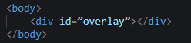
- Adding of the CSS – Styling of the overlay element:
  - 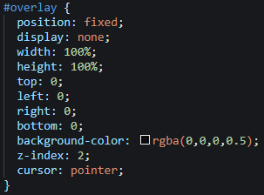
- Adding of the JavaScript – Turns the overlay effect on/off:
  - 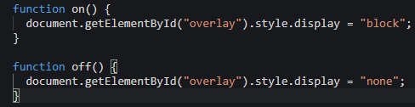

Creation of an Overlay Effect – provides a gradient effect:
- For this there are no specific HTML elements required.
- Adding of the CSS code – https://imagekit.io/blog/css-image-overlay/ [Example Code]:
  - 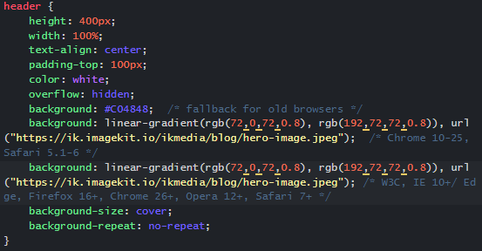

Old/ “Clunky” Way:
This method works but is more outdated and uses only HTML structures, then using an “image-box”, that has been relatively positioned. Once done they’re stacked and placed into the desired order.
- HTML Code – div elements (multiple):
  - 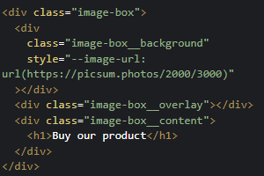
- CSS Code
  - 